User Guide :- Doordash Product

## Background:

The document is a user guide created for the end-user and the operation team to get familiarized with the product and its usage. The detailed architecture and the call flow are out of scope of this document.

## Details:

The high level architecture of the Doordash delivery system is depicted below :

Mobile App and backend

Robot Delivery and re-routing

The main features of the product are :

1. Mobile app and the backend : The mobile app helps the user to login and order the food. The order is the recorded in the database of the Doordash delivery system’s database, the notification is sent to the user about the order placed and the estimated time of delivery.

The user logs in with his credentials using login page of the Doordash mobile app as shown in the below figure

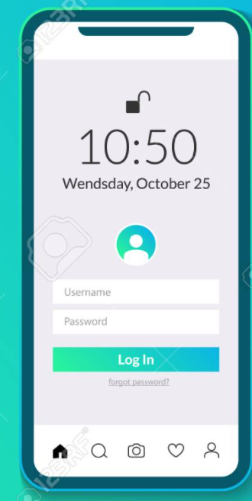

There is a recovery option of username and password, where in the user can click the forgot password option.

1. Doordash delivery system : The Doordash delivery system is the backend and all the business logic is implement in this platform. The Doordash delivery system provides the Realtime tracking, re-routing and notification features. The operations team members have access to this back-end system which has the privileges to interact with the Dashdoor robot in real time and can re-route it if there is a request from the user to do so. Also, the Doordash has built in analytics engine for the analysis of the orders received and the management make informed decisions or change strategy based on the outcome.

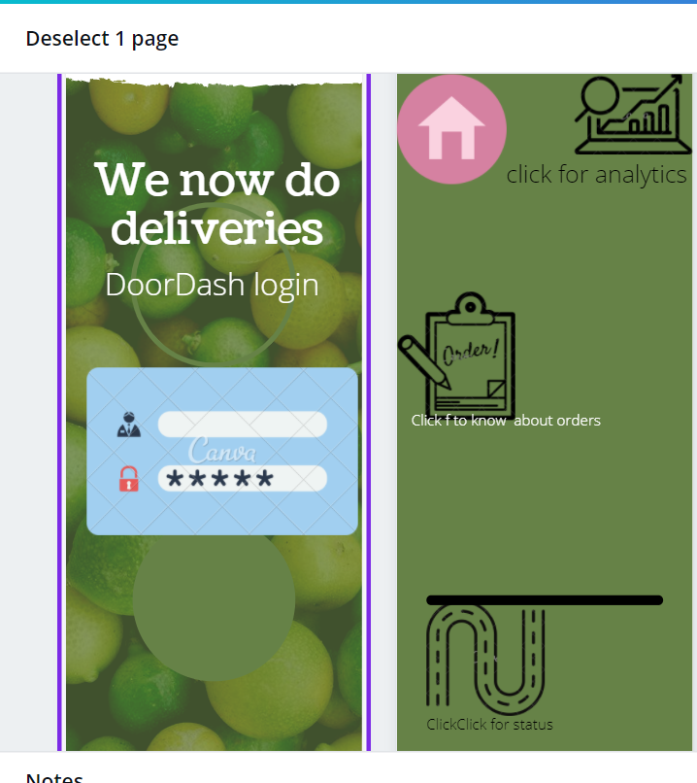

The above figure is the backend of the Dashdoor for the operation team and the customers, it has icons to know the status of the robot, analytics and robot tracking with click of respective icons.

1. Robot delivery and re-routing : This feature is responsible for the delivery of the food product and also re-routing of the address upon the request from the user in real time . The operations team member triggers this event and then the robot re-routes itself to deliver the order to the new address.

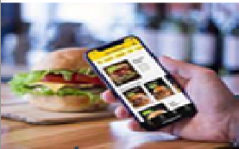

Re-route request

Acknowledgement and Notification



Doordash backend system

The user selects the re-route option with the new address, this triggers notification to the backend system, which in turn the operation team commands the robot to re-route it to the new address.